SECTION LA

AIR INTAKE FILTERS

CONTENTS

Chapter

Removal and Cleaning Filter Panels .. .. .. .. .. 1

Removal and Fitting of Filter Assembly .. .. .. .. .. 2

CHAPTER 1

REMOVAL AND CLEANING OF FILTER PANELS

1. Release clips (3) and remove retaining frame (24). Withdraw filter panel (2) from casing (5) using handles (1).
2. Immerse the filter panel in a solvent bath, dirty side down, and soak to loosen the dirt. Gently agitate the panel to wash any dirt off the filter mesh. If necessary, immerse the panel in a second clean bath of solvent.

NOTE Recommended solvents are 'Colosyl' or 'Tri-sodium Phosphate' mixed with water.

1. Stand the filter panel on edge and allow to drain; drainage holes are provided in the channels enclosing the edge of the panel. Ensure that the filter is thoroughly dried after draining.
2. Recharge the panel by immersing in 'FILTERCOAT' oil and allow to drain.
3. Check sealing strip (15) for condition and security. If necessary a new strip should be fitted, bonding it into position with 'Walkers TICO’.
4. Locate retaining frame to the filter panel, refit to casing and secure with spring clips. When inserting the panel in the casing, ensure that it is firmly bedded on to the sealing strip.

CHAPTER 2

REMOVAL AND FITTING OF FILTER ASSEMBLY

1. Remove the filter panels from the engine as described in Chapter 1. Remove setscrews (18), philidas nuts (16) and washers (17). Support casing (5) whilst removing setbolts (22) and plain washers (23).
2. Remove setbolts (12) and (14), and plain washers (13). Remove air inlet casing (6) from the turbocharger.

Inspection

1. Examine all components for cracks and welding failure. Check sealing strip (15) for condition and security. Re-bond to the casing if necessary using 'Walkers TICO'. Check springs (4) for stretch and clips (3) for wear and burring. Check retaining frames (24) for distortion and the securing hooks for security. Check all threaded components for serviceability.

Fitting

NOTE All joints and 'O’ rings must be fitted dry.

1. Secure air inlet casing (6) to the turbocharger with setbolts (12) and (14), and plain washers (13). Offer up and secure casings (5) with setbolts (22) and plain washers (23). Fit setscrews (18), plain washers (17) and philidas nuts (16).
2. Locate retaining frame (24) to filter panel (2) and fit to casing (5) using clips (3).

|  |  |  |  |
| --- | --- | --- | --- |
| Key To Numbers  1. Handle | | 13. | Plain washer |
| 2. | Filter panel | 14. | Setbolt |
| 3. | Clip | 15. | Sealing strip |
| 4. | Spring | 16. | Philidas nuts |
| 5. | Casing | 17. | Plain washer |
| 6. | Air inlet casing | 18. | Setscrew |
| 7. | Filter support 'A' bank | 19. | Filter support 'B' bank |
| 8. | Philidas nuts | 20. | Plain washer |
| 9. | Plain washer | 21. | Setbolt |
| 10. | Bracket | 22. | Setbolt |
| 11. | Setscrew | 23. | Plain washer |
| 12. | Setbolt | 24. | Retaining frame |

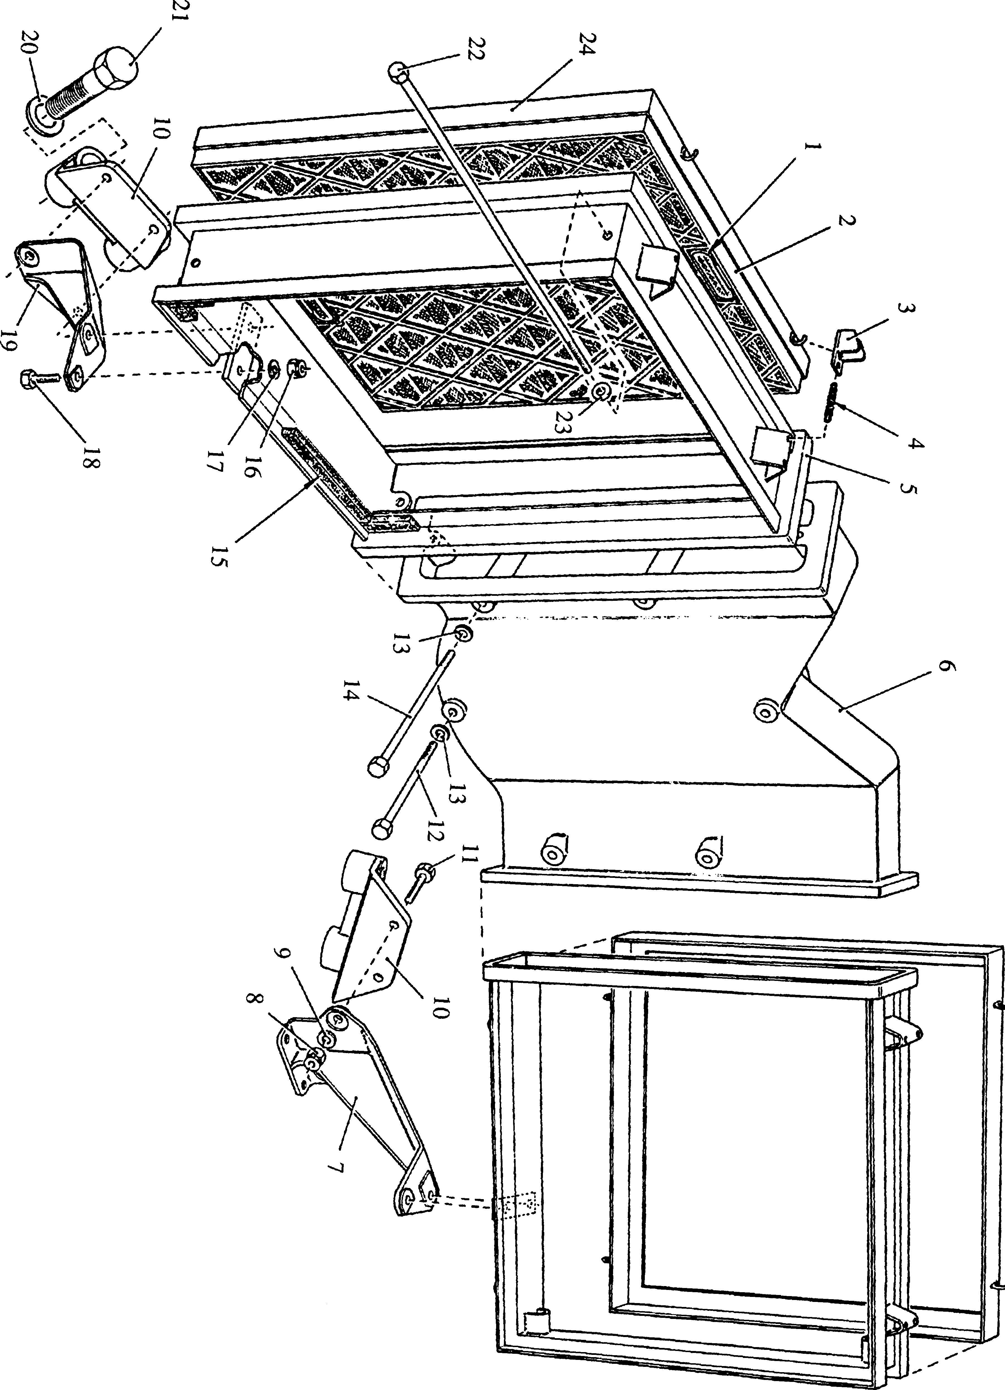

**SPD00508**

Fig LA.l Air intake filter